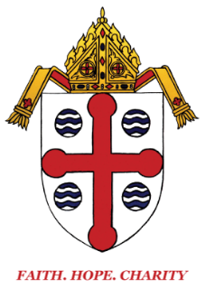
Diocese of Springfield
Committee for the Continuing Education, Formation and Support of Clergy

TO: Active and Retired Priests and Deacons
FROM: Fr. Warren J. Savage
DATE: December 1, 2022
RE: Advent Eucharistic Holy Hour

On behalf of Bishop Byrne, I would like to invite our priests and deacons to come together for the Advent Eucharistic Holy Hour on Tuesday, December 13, 2022, from 2:30 p.m. to 3:30 p.m., at St. Michael’s Cathedral. This will be a time for prayer, reflection, and a spiritual talk. Confessors will be available for the Sacrament of Penance.

Our presenter for the day is Fr. James McCurry, OFM Conv. He is the Minister Provincial Emeritus of the Franciscan Friars Conventual of Our Lady of the Angels Province, which encompasses the east coast of the United States; Ontario, Canada; Rio De Janeiro, Brazil; Ireland and Great Britain.

Born in Ludlow, Massachusetts, and having graduated from Boston College, he entered the Franciscan Order in 1970, and was ordained to the Holy Priesthood in 1977. He holds a BA and an MA in English from Boston College, and an M.Div. from St. Anthony-on-Hudson Theological Seminary, Rensselaer, New York.

Fr. James is a past President of the Mariological Society of America, and currently its Vice-President, and a correspondent appointee to the Pontifical International Marian Academy in Rome. He is on the Boards of Directors of the Institute on Religious Life and the Cardinal Kung Foundation.

For over forty-five years, he has lectured, conducted retreats, led pilgrimages, and preached in all fifty states of the US, as well as 65 countries of the world, on all seven continents. He authored Maximilian Kolbe: Martyr of Charity (London, CTS Publications).

He has published numerous articles and booklets, and has appeared on radio, television, and video broadcasts. His "Mariology" series on the Eternal Word Television Network was syndicated for several years. He presently resides at Pope St. John Paul II Friary in Holyoke, Massachusetts.

Please RSVP to Stacy Dibbern by Friday, December 9, 2022.

May our love increase more and more in knowledge and every kind of perception, to discern what is of value, so that we may be pure and blameless for the day of Christ (Philippians 1:9-10).

